Course: Design Analysis And Algorithm Name: Pooja S
Code: CSA0606 Regno:192524211
Date:07.10.2026 Slot: B
Session-4 Lab Programs

14. s = input("Enter a string: ")
result = []
i = 0
while i < len(s):
j = i
while j < len(s) and s[i] == s[j]:
j += 1
if j - i >= 3:
result.append([i, j - 1])
i = j
print(result)
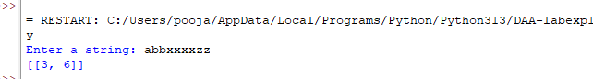

15. def gameOfLife(board):
m = len(board)
n = len(board[0])
new_board = [row[:] for row in board]
for i in range(m):
for j in range(n):
live = 0
for x in range(max(0, i - 1), min(m, i + 2)):
for y in range(max(0, j - 1), min(n, j + 2)):
if (x, y) != (i, j):
live += board[x][y]
if board[i][j] == 1:
if live < 2 or live > 3:
new_board[i][j] = 0
elif live == 3:
new_board[i][j] = 1
return new_board
board = [
[0, 1, 0],
[0, 0, 1],
[1, 1, 1],
[0, 0, 0]
]
result = gameOfLife(board)
for row in result:
print(row)
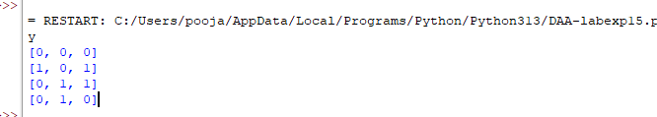

16. def champagneTower(poured, query_row, query_glass):
tower = [[0.0] * 101 for _ in range(101)]
tower[0][0] = poured
for i in range(query_row + 1):
for j in range(i + 1):
if tower[i][j] > 1:
excess = tower[i][j] - 1
tower[i + 1][j] += excess / 2
tower[i + 1][j + 1] += excess / 2
return min(1.0, tower[query_row][query_glass])
poured = int(input("Enter poured: "))
query_row = int(input("Enter query row: "))
query_glass = int(input("Enter query glass: "))
result = champagneTower(poured, query_row, query_glass)
print(f"{result:.5f}")
